**- SGD 1 = ¥70 i.e. ¥1000 = SGD 14.2**

**- Tokyo time is 1 hour faster than Singapore, i.e. sun set earlier**

**- Expected Weather Forecast in January : 0 to 9 degree celsius**

**- Expected mandatory expenses (e.g. train, bus, attraction entry tickets) is around 500 SGD**

**- Expected basic meals expenses is around 500 SGD**

|  |  |  |  |  |  |
| --- | --- | --- | --- | --- | --- |
| **Date** | **Start Time** | **End Time** | **Activity** | **Remarks** | **Mandatory**  **Cost (est)** |
| **Thur**  **24 Jan** | **11pm** | **11pm** | Meet Up and Check in Luggage | Remember to bring passport |  |
| **Thur**  **24 Jan** | **1130** | **0030** | Dinner/Supper | - Eat more because the journey is very long (14 hours to hotel), around 2pm then will have chance to eat lunch  - Buy some food (bread etc) to be eaten during the the journey |  |
| **Friday**  **25 Jan** | **0055** | **1040** | Flight from SG to TOKYO, Narita T2 via Taipei stopover 45 mins |  |  |
| **Friday**  **25 Jan** | **1040** | **1130** | Arrived at Narita International Airport Terminal 2. Usually will have delay till 11 plus  - Collect Baggage  - buy train tickets **(Suica & NEX )**  - take brochures  - buy phone card (optional)  Check on trains route  http://www.hyperdia.com | Suica & NEX is a discount ticket package for foreign travelers arriving at Tokyo's Narita Airport. It provides transportation from the airport into the city by the Narita Express train (NEX) and a Suica prepaid card for use on urban transportation at a highly discounted price. The Suica & NEX packages consists of  **(a)** a ticket that can be used to travel from Narita Airport into Tokyo and  **(b)** a Suica prepaid card valued 2000 yen that can be used on urban transportation in the Greater Tokyo region.  Round trip, ordinary card cost : 5,500 yen, value of 500 yen is refundable. Please be reminded that when you have the suica card deposit refunded, make sure you have no credit balance left on it, otherwise JR charges you a handling fee of 210 yen for the credit balance refund.  http://gutereise09.blogspot.sg/2008/07/narita-express-to-tokyo-proper-japan.html | $85 for narita airport return train card and some value to be used in tokyo |
| **Friday**  **25 Jan** | 1130 | 1400 | Travel to hotel. (**refer to appendix)**  - Train journey is around 1hr 45mins.  - 15 Mins walk from shinjuku station to keio plaza hotel(<http://gutereise09.blogspot.sg/2008/07/access-to-keio-plaza-hotel-from.html>)  - Check in, lock passport, settle down and go out | - Hotel check in timing is 2pm |  |
| **Friday**  **25 Jan** | 1400 | 1530 | Search for tour packages and attraction tickets around shinjuku while making our way to Harajuku Station  Head to Takeshita Dori (**Harajuku Station**) for lunch and shop  **refer to appendix** on how to go to takeshita dori  **Harajuku Station** is a station on the JR Yamanote Line, two stations south of Shinjuku and one station north of Shibuya (130 yen from either station). | **Lunch**  A bowl of ramen at **Kyusyu Jangara** (Jingumae 1-13-21, Shibuya-ku; 3404-5572; 10.45am-3am; JR Yamanote Line to Harajuku (Omote-sando exit), Chiyoda or Fukutoshin Line to Meiji-jingumae exit 3) sets you back at ¥700-¥1000 (S$10.50-$15). Sesame oil broth is reminiscent of Nissin noodles but much, much more savory, good till the last drop. The best thin noodles I ever had. Char siew (roasted pork) is silky and very flavorful. A pity about the egg–too hardboiled.  <http://www.japan-guide.com/e/e3006.html> |  |
| **Friday**  **25 Jan** | 1530 | 1630 | **OTOT Shopping (1hr)** | **Takeshita Dori (**Shops along Takeshita Dori tend to be open daily from 11:00 to 20:00.)  The symbol of Harajuku and birthplace of many of Japan's fashion trends, Takeshita Dori (Takeshita Street) is a narrow, roughly 400 meter long street lined by shops, boutiques, cafes and fast food outlets targeting [Tokyo](http://www.japan-guide.com/e/e2164.html)'s teenagers. Because of the street's popularity, it becomes extremely busy and crowded on the weekends. Interesting shops and restaurants can also be found along some of the side streets.  The flagship stores of Japanese designers are all around this area so if you have cash to spare, **visit Comme Des Garcons, Issey Miyake, and Yohji Yamamoto.** |  |
| **Friday**  **25 Jan** | 1630 | 1700 | Walk to Shibuya, only 1 station away (**Harajuku Station** - Shibuya Station) |  |  |
| **Friday**  **25 Jan** | 1700 | 1800 | **OTOT Shopping (1hr)** | **Place to shop in shibuya**  - Tokyo Hands (Udagawacho 12-18, Shibuya-ku; 5489-5111; website; 10am-8.30pm) – similar to Mustafa in Singapore, it sells everything you ever need and not need.  -Loft (Udagawacho 21-1, Shibuya-ku; 3462-3807; 10am-9pm): Like Mustafa catered to a younger, trendier crowd.  -Center Gai. The birthplace of many Japanese fashion trends, Center Gai is a busy pedestrian zone in the heart of Shibuya lined by stores, boutiques and game centers. In the evenings the street is crowded with young people heading to night clubs, restaurants and bars, or just loitering around. |  |
| **Friday**  **25 Jan** | 1800 | 1900 | Have dinner at Shibuya  and decide whether to   * back change and go to womb * back back change and go to Roppongi Hill * Head back to shinjuku and visit the skyscraper (Tokyo Metropolitan Government Office (TMG) | **Place to Eat in Shibuya**  **- Go Go Curry** (Basement, 12-12 Udagawa-cho, Shibuya-ku; 03-6231-5534; website) epitomizes the kitschy, make-believe world of Japan. The jingle played continually while we were there. A vending machine ticketing style. There was a helpful server who speaks Mandarin. About ¥700 (S$10).  - **Kujiraya, Dogenzaka** 2-29-22 (Bunkamura-dori, just past 109, opposite Baskin-Robbins.), ☎ +81 03-3461-9145, [16]. The specialty and only food here is whale meat dishes, which are very rare elsewhere. Don't forget to pick up a pro-whaling propaganda pamphlet on your way out. Lunch sets from ¥1300, dinner ¥2000 up. edit  - **Kyotako,** (right next to Tokyu Hands). A famous store for takoyaki octopus balls. |  |
|  | 2300 | 0100 | (Optional) Womb only open after 2300  2-16 Maruyama-cho, Shibuya  **(refer to appendix on how to go to womb from shibuya)** | Womb’s incredible laser system played a major role in that scene and it is a central part of the experience at this cavernous space discreetly located on Love Hotel Hill in Shibuya.  It’s not just the lasers though; Womb regularly draws international artists such as The Chemical Brothers, Sven Vath and John Digweed.  You will almost always see Womb in the Top Ten on World’s Best Clubs lists and, just for good measure, it also has Japan’s biggest mirror ball. |  |
| **Friday**  **25 Jan** | 2200 | 0000 | Back to hotel showered and sleep |  |  |
| **Friday**  **25 Jan** | 0000 | 0700 | Sleep | Before sleep may consider to fill up glasses of water and leave it in room and let it evaporates in the air to prevent dryness to throat |  |
| **Saturday**  **26 Jan** | 0700 | 0800 | Wash Up and Ready to **go out by 8am**. Head direct to Tsukiji Market for breakfast | Dont dilly dally. Sequence to wake up to shower  **1. ZhongDe, 2. Peter, 3. Andy.** |  |
| **Saturday**  **26 Jan** | 0800 | 0830 | **Head to Tsukiji Market** | Tsukiji Market stays open until 1pm, though the real action does not exactly happen beyond 8am, and **many shops close after 10am.** | $4 train ride |
| **Saturday**  **26 Jan** | 0930 | 1100 | Sashimi brekkie at **Daiwa Sushi** | **Two shops attract the longest queue – Sushi Dai (寿司大) and Daiwa Sushi (大和寿司).** Many chose to walk in random shops during their visits, without the queue, and their standards won’t be too far off.  For something very similar in quality and a much shorter queue, move to a shops away at **Daiwa Sushi**, which is actually run by the son of the owner of Sushi Dai. It is said that the father and son team fish together and compete to see who can catch and make the best sushi in Tsukiji.  The Omakase chef’s choice is **3,500 yen (SGD$55, USD$45)** for seven sushi and one roll. If you work the sums, each sushi will be about $7 – much more expensive than usual. The flavours will depend on the catch of the day, typically including ebi (shrimp), uni (sea urchin), hamachi (yellowtail), tamago (sweet egg), tuna rolls, as well as a bowl of miso and green tea.  *buy preserved scallop | Must eat sushi for around $60 |
| **Saturday**  **26 Jan** | 1100 | 1200 | **Head to Tokyo Sky Tree** | http://www.tokyo-skytree.jp/en/ | $5 train ride |
| **Saturday**  **26 Jan** | 1200 | 1400 | Spend time in Sky Tree observatory tower.  Purchase tickets on the day at the "TOKYO SKYTREE 4th floor Ticket Counter" | Refer to appendix for ticket price  * there is also an aquarium but dont think is worth visting at $30 | $30 for Sky Tree Entrance |
| **Saturday**  **26 Jan** | 1400 | 1630 | Lunch at Tokyo Solamachi and shop around |  |  |
| **Saturday**  **26 Jan** | 1630 | 1700 | **Head to Tokyo Dome** | http://www.tokyo-dome.co.jp/e/attractions/ |  |
| **Saturday**  **26 Jan** | 1700 | 2000 | **Options to choose the following or OTOT:**  **Take the rides in Tokyo Dome Attraction**  **(Y2800, $42 - night pass)**  - Roller coaster (but close)  - Big O ferries wheel  - Wonder Drop etc  **Tokyo Dome Roller Skate Arena**  **(Y2000, $30)**  Tokyo Dome Roller Skate Arena is one of the largest indoor roller-skate rinks in Tokyo. People from all ages, both children and adults can enjoy skating together. Short lessons are also provided by specialized instruction, so beginners are welcome too!! | Other Options  **Sauna Tokyo Dome**  **(Y3000, $45)**  sauna with luxury lounge space, three types of baths and three types of saunas. Quality body care service, acclaimed by sport athletes including professional baseball players, is also available. Spend some relaxing time to relieve your fatigue at the downtown oasis. | $50 |
| **Saturday**  **26 Jan** | 2000 | 2100 | **Dinner**  - Washoku-Enn  - GINZO  - Shunpu Banri |  |  |
| **Saturday**  **26 Jan** | 2100 | 2200 | Head back to hotel |  |  |
| **Saturday**  **26 Jan** | 2200 | 2300 | Back to hotel showered and sleep |  |  |
| **Sunday**  **27 Jan** | 2300 | 0600 | Sleep | Before sleep may consider to fill up glasses of water and leave it in room and let it evaporates in the air to prevent dryness to throat |  |
| **Sunday**  **27 Jan** | 0600 | 0700 | Wash up. **Ready to go out by 7am.**  *Can sleep in the bus or train during the journey to Mt Fuji  * bring your thickest clothes, the places that we will be visiting will be super cold | Dont dilly dally. Sequence to wake up to shower  **1. Peter, 2. Andy, 3.ZhongDe** |  |
| **Sunday**  **27 Jan** | 0700 | 0800 | Quick Breakfast around hotel vincinity (not sure if any shops open this early) if not then we will have breakfast in Gotemba Station.  Catch the 0830 bus from shinjuku to Gotemba Station |  |  |
| **Sunday**  **27 Jan** | 0800 | 1010 | Journey to Gomtemba |  |  |
| **Sunday**  **27 Jan** | 1100 | 1100 |  | http://www.hakonenavi.jp/english/index.html |  |
| **Sunday**  **27 Jan** | 1100 | 1230 | Lake ASHI |  |  |
| **Sunday**  **27 Jan** | 1230 | 1300 | HOKONE ROPEWAY, aka Cable Car |  |  |
| **Sunday**  **27 Jan** | 1300 | 1430 | Premium Outlet |  |  |
| **Sunday**  **27 Jan** | 1430 | 1600 |  |  |  |
| **Sunday**  **27 Jan** | 1600 | 1630 |  |  |  |
| **Sunday**  **27 Jan** | 1630 | 1800 |  |  |  |
| **Sunday**  **27 Jan** | 1800 | 1900 |  |  |  |
| **Sunday**  **27 Jan** | 1900 | 2100 | Head back to Shinjuku |  |  |
| **Sunday**  **27 Jan** | 2100 | 2300 | Walk around shinjuku to have supper |  |  |
| **Sunday**  **27 Jan** | 2300 | 0000 | Back to hotel, shower and sleep |  |  |
| **Sunday**  **27 Jan** | 0000 | 0700 | Sleep | Before sleep may consider to fill up glasses of water and leave it in room and let it evaporates in the air to prevent dryness to throat |  |
| **Monday**  **28 Jan** | 0700 | 0745 | Wash up. **Ready to go out by 7:45 am.** | Dont dilly dally. Sequence to wake up to use the toilet  **1.. Andy, 2.ZhongDe, 3.Peter** |  |
| **Monday**  **28 Jan** | 0745 | 0900 | Breakfast around the vicinity of our hotel |  |  |
| **Monday**  **28 Jan** | 0900 | 1000 | Travel to disney sea  (refer to appendix on how to head disney sea) |  | Park admission ticket 6,200 and 4,900 yen |
| **Monday**  **28 Jan** | 1800 | 1900 | Head back to shinjuku |  |  |
| **Monday**  **28 Jan** | 1900 | 2030 | Have dinner |  |  |
| **Monday**  **28 Jan** | 2030 | 2230 | Golden Gai in Shinjuku - drinking | Before sleep may consider to fill up glasses of water and leave it in room and let it evaporates in the air to prevent dryness to throat |  |
| **Monday**  **28 Jan** | 0000 | 0700 | Sleep | Before sleep may consider to fill up glasses of water and leave it in room and let it evaporates in the air to prevent dryness to throat |  |
| **Tuesday**  **29 Jan** | 0700 | 0800 | **Ready to go out @ 0800** | Dont dilly dally. Sequence to wake up to use the toilet  **1.. Peter, 2.ZhongDe, 3.Andy** |  |
|  | 0800 | 1000 | Head DiverCity Tokyo Plaza  ( have breakfast in shinjuku or Odaiba ) |  |  |
|  | 1000 | 1200 | Shop at DiverCity Tokyo Plaza | This new shopping, dining and entertainment complex opened on April 19, 2012. Its most unique attraction is the Gundam Front Tokyo with various attractions and a shop centered around the anime series' robots. A "life sized" Gundam statue stands in front of the building. |  |
|  | 1200 | 1330 | Head Palette Town - Venus Fort |  |  |
|  | 1330 | 1430 | Have lunch @ Venus Fort | Venus Fort is a shopping mall in the style of a 18th century South European town. The mall features over a hundred shops, fashion boutiques, cafes and restaurants on three floors including a few **outlets shops** on the upper floor. |  |
|  | 140 | 1600 | Shop @ Palette Town - Venus Fort |  |  |
|  | 1600 | 1630 | Head to Oedo Onsen Monogatari (SPA) | Opened in 2003, Oedo Onsen is a hot spring theme park which reproduces the atmosphere of the Edo Period. Here you can enjoy various types of indoor and outdoor baths which are fed by hot spring water pumped from a depth of 1400 meters. Restaurants, massage, games and other entertainment, as well as overnight stays are available. |  |
|  | 1630 |  |  |  |  |
|  |  |  |  |  |  |
| **Wed**  **29 Jan** | 0730 | 0830 | Wash up. **Ready to go out by 8am.**  Check out hotel. Remember to take back deposit if its in cash | Dont dilly dally. Sequence to wake up to use the toilet  **1.ZhongDe, 2.Andy, 3.Peter** |  |
| **Wed**  **29 Jan** | 0830 | 1000 | Head to Narita International Airport Terminal 2. |  |  |
| **Wed**  **29 Jan** | 1000 | 1015 | Check in luggage |  |  |
| **Wed**  **29 Jan** | 1015 | 1130 | Eat brunch. Eat more again because journey back is 10 hours |  |  |
| **Wed**  **29 Jan** | 1150 | 2010 | Home Sweet Home |  |  |

**Mt Fuji Comments**

I did that last year, very pleasant. You could do it a few ways, better buy a Hakone Freepass which includes rides on trains, buses, cable cars, boat trips in Hakone- worth it- saves both time and $.

The simple route is;

A. Odakyu train from [Shinjuku](http://www.tripadvisor.com.sg/Tourism-g1066457-Shinjuku_Tokyo_Tokyo_Prefecture_Kanto-Vacations.html) station- book the 'Romance Car limited Express" which goes directly to Hakone-Yumoto station, the Hakone trip starts from there. (About 1.30 hour one way) Get your freepass from Odakyu Travel counter at Shinjuku station, weekdays pass for adult is Y5,500 and include this train from Tokyo which one way on its own is already Y2,000.

The fastest route, best for people with JR rail pass is;

B. JR Shinkansen train Tokaido line from Tokyo station to Odawara, only 40 min! Then buy your Hakone freepass from Odakyu Travel at this station (weekdaypass is Y3,400.) Then get on the Odakyu train to Hakone -Yumoto, only 15 min away.

The shinkansen ticket without JR rail pass costs about Y3,600 one way.

From Hakone -Yumoto,

1. Get on the "Hakone -Tozan Mountain railways, scenic route up the mountain to Gora Station (35 min) I recommend you stop one station before Gora (Chokoku-no-mori) to visit "the Hakone Open Air museum". It is one of the most wonderful museum, with marvellous sculptures from Henri Moore, Rodin, Miro, etc artistically displayed in its large valley landscape. They also have a big Picasso Pavillion with lots of work from his early years till the end. They even have a foot spa for you to relax your feet in hot flowing water.

(Ticket Y 1,600- some discount for freepass holder)

2.Then go on the cable car from Gora to Souzan, connect to Hakone Ropeway which stops at Owakudani, about 15-20 min. You could walk 15 min to see the black egg thing boiled and get on another ropeway to go further to Togendai by Ashi Lake- about 20 min. On a clear day you should see Fujiyama :)

3. At Togendai, get on board the Hakone Kankosen boat, the lake trip will be about 40 min. Get off at Hakone Machi. You could walk around this small town and get on a bus back to Hakone-Yumoto or Odawara.

Some people skip the boat ride& go from Togendai to Gotemba by bus, all rides include in freepass. There's also an Odakyu bus from Shinjuku to Togendai on the lake, about 2 hours. But I think it is pleasant by train- and much faster.

Hope you enjoy!

**Flight Itinerary**

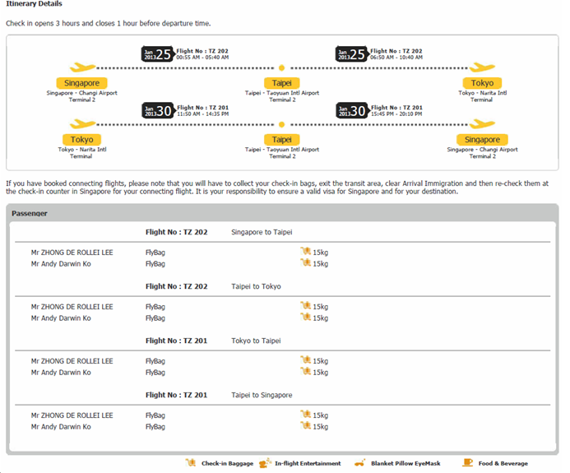

**Hotel Itinerary**

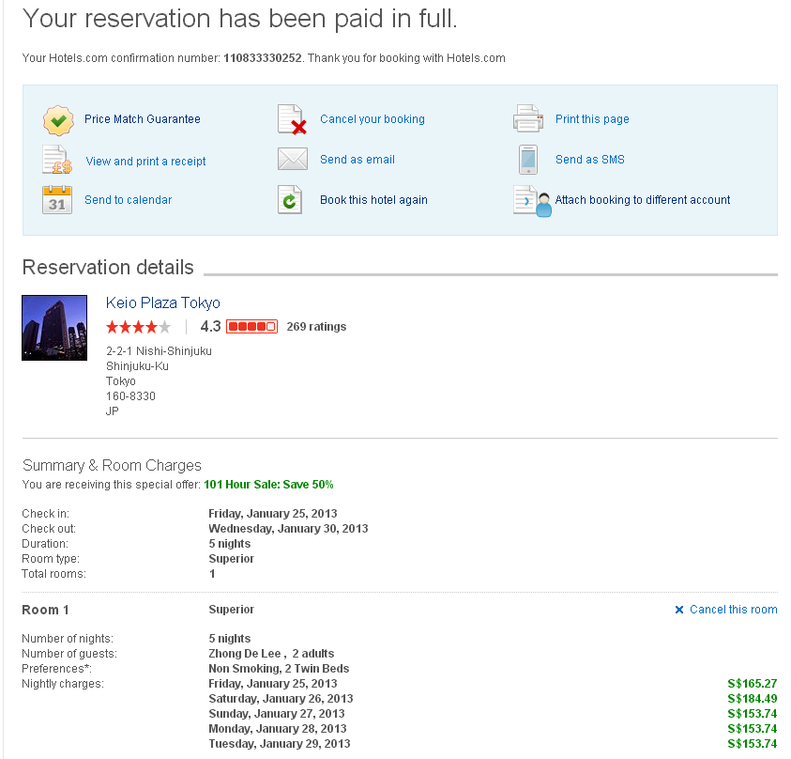

**Train cards to be purchased at Narita Airport**

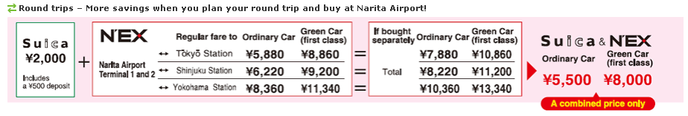

**Narita Airport to Shinjuku Station**

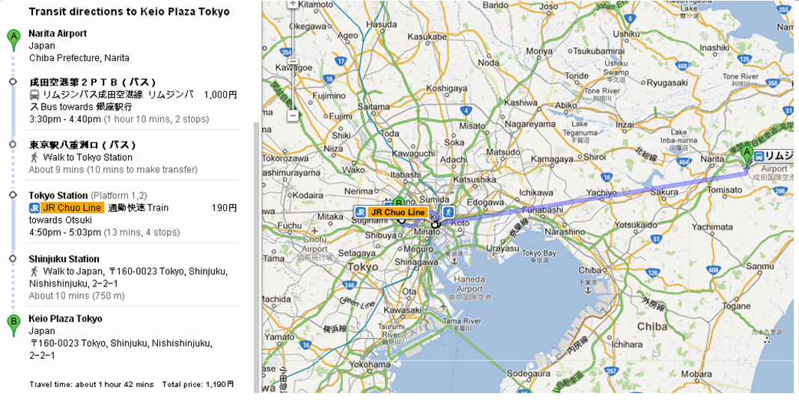

**Shinjuku Station to Hotel**

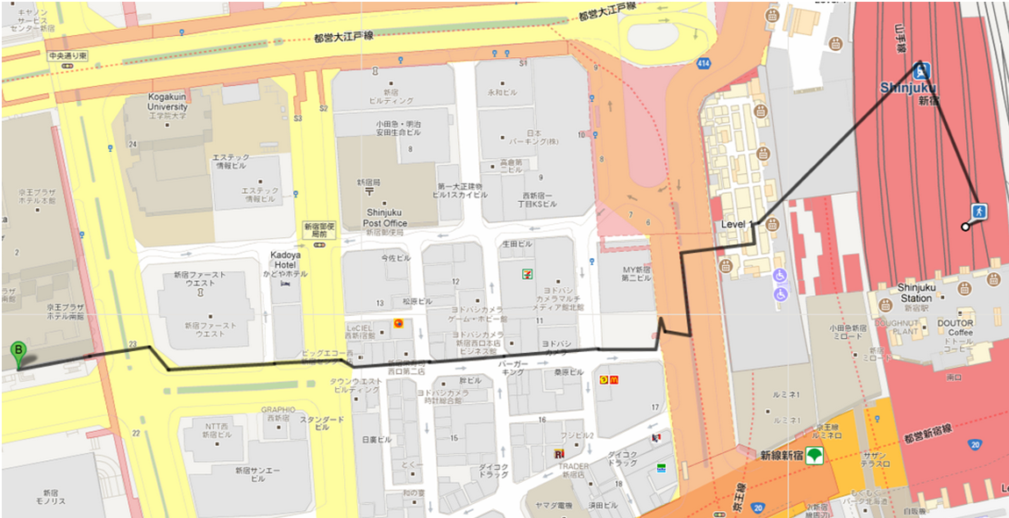

**Keio Hotel to Takeshita Street**

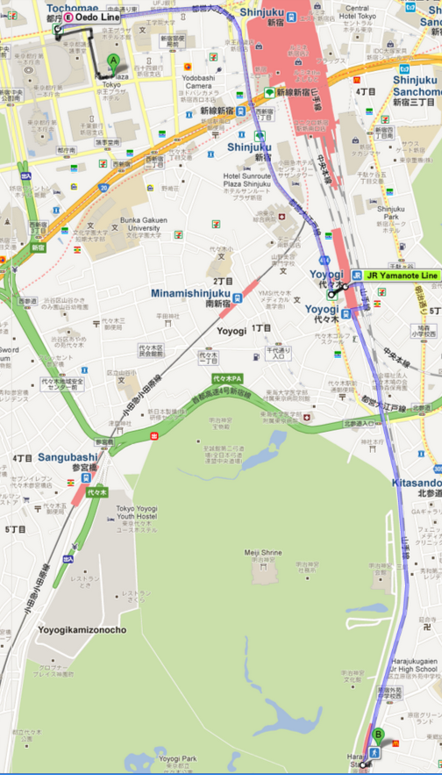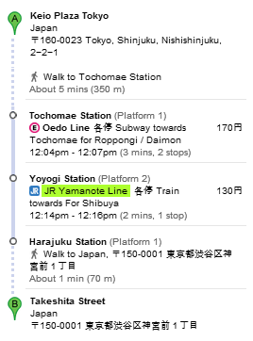

**Tsukiji Market**

-**Tsukiji Fish Market** ([website](http://www.tsukiji-market.or.jp/); closed 2nd and 4th Wed of the month, Sun and PH). #1 tourist spot for Tokyo. The auction only allows 100 viewers a day. **Head to the office by 4.30am**. But when we were there at 4.30am, the auction was already over that day. Visitors can explore the market after 9am.

After Tsukiji Fish Market, tradition calls for a sushi breakfast. You have to walk behind the market through the dangerous thoroughfares where mini-vehicles use to carry fish may knock you down at any moment. Be careful.

There are two sushi restaurants, side-by-side, to choose from **Sushi Daiwa** (大和. Bldg 6, Tsukiji 5-2-1, Chuo-ku; 3547-6807; 5.30am-1.30pm M-Sat) and **Sushi Dai** (大. , 6-21-2 Tsukiji, Chuo-ku; 3541 3738; 5am-1pm). **Sushi Daiwa** has a bigger restaurant so the queue moves faster–takes about **2 hours of queue**–but it also has more tourists queuing up. **Sushi Dai** has more Japanese queueing but **takes 4 hours** for your turn. We opted for **Sushi Dai**.

**This was the queue at 4.40am**:

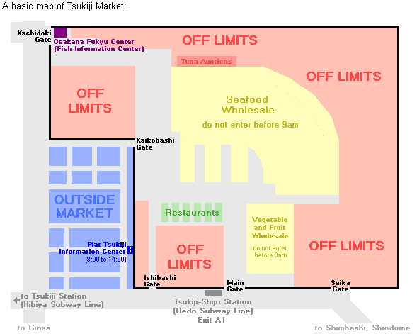

We got in **1 hour 45 minutes** later.

It was worth the waiting time. Every single second of it. The sushi is spectacular and the rice is warm and My eating partner unconsciously closed his eyes and gave an orgasmic look on his face, like he were on one of those Taiwanese TV eating show. He said he felt so happy after the meal and he didn’t want to eat anything else to taint the memory of the sushi.

**Sky Tree**

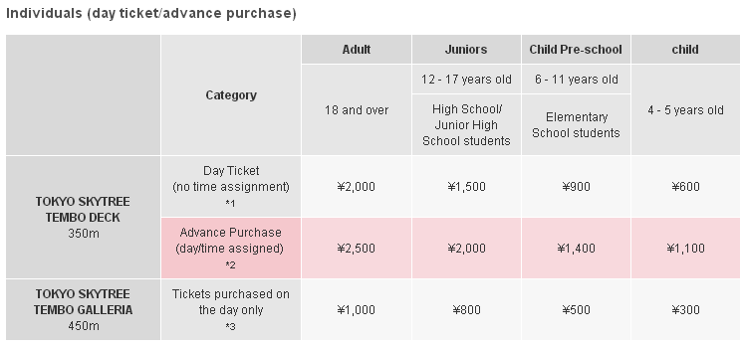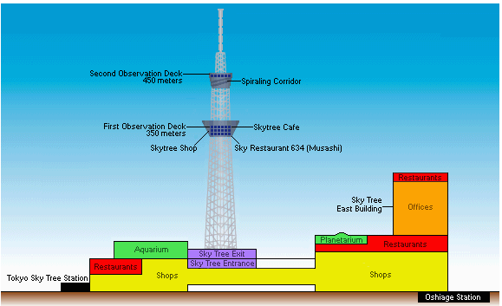

**MT Fuji**

<http://forums.hardwarezone.com.sg/japan-271/mount-fuji-day-tour-2755065.html>

<http://forums.hardwarezone.com.sg/japan-271/japan-thread-season-3-updates-share-your-experience-1284932-737.html>

<http://www.st-inn.com/english/direction.html>

<http://www.st-inn.com/english/direction.html>

Take the JR Chuo Line from Tokyo or Shinjuku Station to Otsuki (70 minutes by direct limited express or 100 min by local trains with one transfer of trains). At Otsuki, change to Fujikyuko Line. Fuji-Yoshida and Kawaguchiko is 50 min. Please note that JR Pass is not valid on the Fujikyuko Line.

Self-Guided Tour to Mt Fuji - <http://www.gojapango.com/travel/mount_fuji.html>

**Mount Fuji Self Guided Tour**

Below is a suggested self guided tour. The times do not include the time you would spend at each attraction. You should also allow extra time at some attraction for queues, particularly the Tenjo-yama Park Mt Kachi Kachi Ropeway. It is not practical visit all of the suggest attractions in one day, so simply drop the attractions that you are less interested in.

|  |  |  |  |
| --- | --- | --- | --- |
| Station/Stop | Transport | Duration | Places to visit |
| [JR Shinjuku](http://www.gojapango.com/tokyo/shinjuku_station.htm) | JR Kaiji | 1h02min |  |
| JR Otsuki | Fujikyuko Railway | 43min |  |
| [Kawaguchiko](http://www.gojapango.com/travel/mount_fuji_kawaguchiko.html) | Retro Bus Kawaguchiko Line | 12 min |  |
| Stop #7, Kawaguchiko Herb-kan | Walk | 1 min | Kawaguchiko Herb Center |
| Stop #8,Yamanashi Hoseki Hakubutsukan | Walk | 1 min | Yamanashi Gem Museum |
| Stop #10, Ropeway Iriguchi | Walk | 1 min | Tenjo-yama Park Mt Kachi Kachi Ropeway |
| Stop #14, Ubuya-mae | Walk | 2 min | Ubuyagasaki |
| Stop #15, Kawaguchiko Bijutsukan | Walk | 1 min | Kawaguchiko Museum of Art |
| Stop #15, Kawaguchiko Bijutsukan | Retro Bus Kawaguchiko Line | 25 min |  |
| Stop #1, Kawaguchiko-eki | Retro Bus Saiko Line | 16 min |  |
| Stop #54, Fuji Omuro Sengen Jinja Shrine | Walk | 1 min | Fuji Omuro Sengen Jinja Shrine |
| Stop #54, Fuji Omuro Sengen Jinja Shrine | Retro Bus Saiko Line | 16 min |  |
| [Kawaguchiko](http://www.gojapango.com/travel/mount_fuji_kawaguchiko.html) | Fujikyuko Railway | 3 min |  |
| Fujikyu Highland | Walk | 1 min | Fuji-Q Highland |
| Fujikyu Highland | Fujikyuko Railway | 2 min |  |
| [Fujiyoshida](http://www.gojapango.com/travel/fujiyoshida.html) | Fujikkogo Bus | 20 min |  |
| Oshino Hakkai | Walk | 5 min | Oshino Hakkai |
| Hananomiyako Koen | Walk | 1 min | Hananomiyako Park |
| Asahigaoka | Taxi | 10 min | Panorama-dai |
| Nagaike Shinsui Koen |  | 1 min | Nagaike Shinsui Park |
| [Fujiyoshida](http://www.gojapango.com/travel/fujiyoshida.html) | Fujikyuko Railway | 46m |  |
| JR Otsuki | JR Kaiji | 1h04min |  |
| [JR Shinjuku](http://www.gojapango.com/tokyo/shinjuku_station.htm) |  |  |  |

Mount Fuji Access

There are several different transport options from [Tokyo](http://www.gojapango.com/tokyo/) to view Mt Fuji.

By train:

[Shinjuku Station](http://www.gojapango.com/tokyo/shinjuku_station.htm) take the JR Chuo Line (45min)

Change trains at Takao Station to the JR Chuo Honsen Line (45min)

Change at Otsuki Station take the Fuji Express (54min)

Arrive Lake Kawaguchi Station for viewing.

Optional - take Fujikyu Yamanashi Bus (50min) to Mt Fuji 5th Station

2390 Yen one way (JR Pass covers first two legs and Fuji Express is an extra 1,110 yen), 1500 yen for optional bus.

By bus:

[Shinjuku Station](http://www.gojapango.com/tokyo/shinjuku_station.htm) take the Fujikyu Bus (145min) to Mt Fuji 5th Station

2600 yen

or

[Shinjuku Station](http://www.gojapango.com/tokyo/shinjuku_station.htm) take the Fujikyu Bus (105min) to Lake Kawaguchi

It goes to Lake Motosu and Lake Yamanaka as well.

1700 yen

If you want to climb Mt Fuji, go to the 5th station.

If you want to view Mt Fuji, go to Lake Kawaguchi, Lake Yamanaka or nearby area.

If you want to travel around the lakes, round-trip tickets are available from Fujikyu Bus & Fujikyu Yamanashi Bus.

Lake Kawaguchi has many attractions while Lake Yamanaka has a quiet environment.

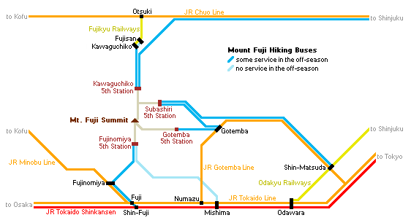

refer to <http://www.japan-guide.com/bus/fuji.html> on the bus timing if we’re taking bus

The **Fuji Visitor Center** is an information center for travelers to Mount Fuji and the Fuji Five Lakes. An information desk on the first floor provides details about climbing and weather conditions, as well as about tourist attractions around the mountain and Yamanashi Prefecture in general.

**From visitor center, find out how to get to fuji 5 lakes**

The Fuji Five Lake (Fujigoko) region lies at the northern base of Mount Fuji about 1000 meters above sea level around the lakes Kawaguchiko, Saiko, Yamanakako, Shojiko and Motosuko. It is one of the best places to view Mount Fuji from a close distance and a good base for climbing the mountain.

<http://www.japan-guide.com/forum/quereadisplay.html?0+70118>

You can use the "retro bus" to get around the area, particularly Lake Kawaguchi and Lake Saiko.

Fujiyama Onsen, next to Fuji Highland is a nice day use spa/onsen and cheap.

<http://www.japanican.com/tours/tourdetail.aspx?aff=GMT&destcd=4&deptcd=TYO&cdt=1&tc=GMT01TYOOF880W&searchfrom=01%2f27%2f2013&searchto=01%2f27%2f2013&pn=2>

<http://wikitravel.org/en/Mount_Fuji>

**Shinjuku to Tokyo Disney Sea**

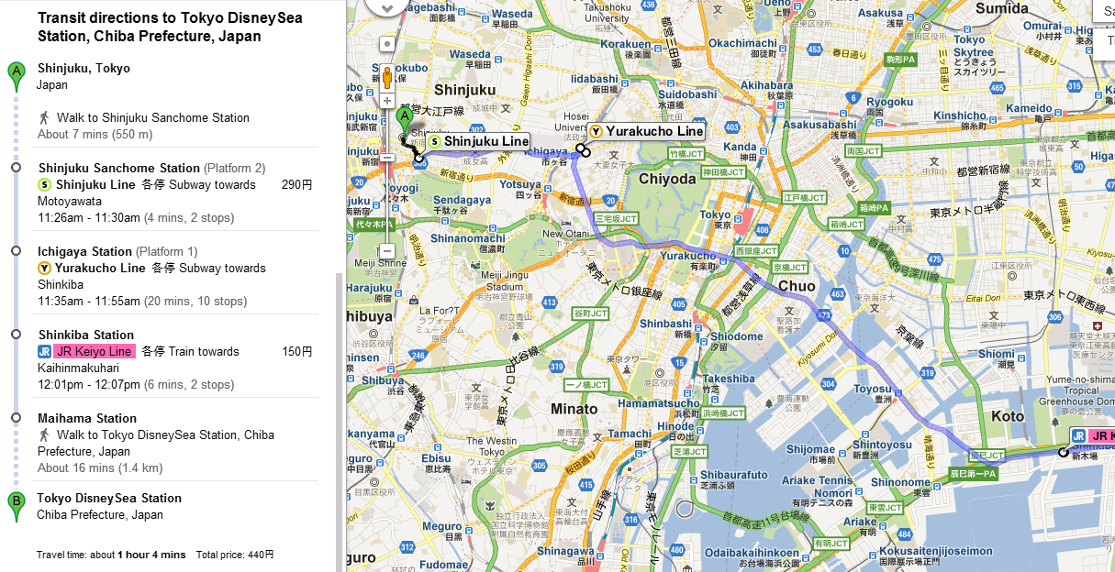

**Map of Odaiba**

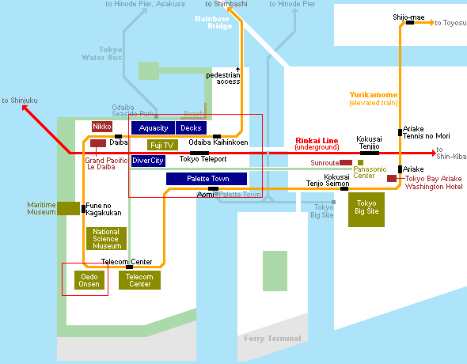

Odaiba (お台場) is a popular shopping and entertainment district on a man made island in Tokyo Bay. It originated as a set of small man made fort islands (daiba literally means "fort"), which were built towards the end of the [Edo Period](http://www.japan-guide.com/e/e2128.html) (1603-1868) to protect [Tokyo](http://www.japan-guide.com/e/e2164.html) against possible attacks from the sea and specifically in response to the gunboat diplomacy of [Commodore Perry](http://www.japan-guide.com/e/e2128.html).

More than a century later, the small islands were joined into larger islands by massive landfills, and Tokyo began a spectacular development project aimed to turn the islands into a futuristic residential and business district during the extravagant 1980s. But development was critically slowed after the burst of the "bubble economy" in the early 1990s, leaving Odaiba nearly vacant. It was not until the second half of the 1990s, when several hotels, shopping malls and the Yurikamome elevated train line were opened, that Odaiba developed into one of [Tokyo](http://www.japan-guide.com/e/e2164.html)'s most popular [tourist attractions](http://www.japan-guide.com/e/e623a.html) and date spots with a wide selection of shopping, dining and leisure options.

Despite the initial setbacks, several lavish development projects did materialize, including some of Tokyo's boldest architectural creations, such as the [Fuji TV Building](http://www.japan-guide.com/e/e3008.html#fuji), [Telecom Center](http://www.japan-guide.com/e/e3008.html#telecom) and [Tokyo Big Sight](http://www.japan-guide.com/e/e3008.html#bigsight). Modern city planning furthermore provides Odaiba with plenty of green space and a pleasant division of motorized and pedestrian traffic using elevated walkways and the like.

**Shinjuku to DiverCity Tokyo Plaza**

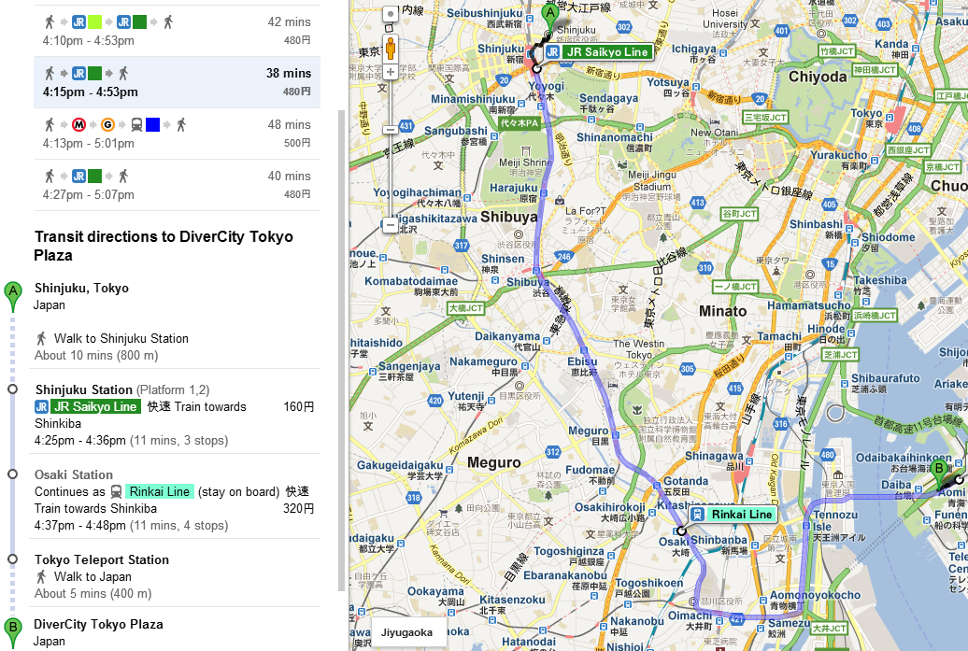

**Shibuya to Womb Club (optional)**

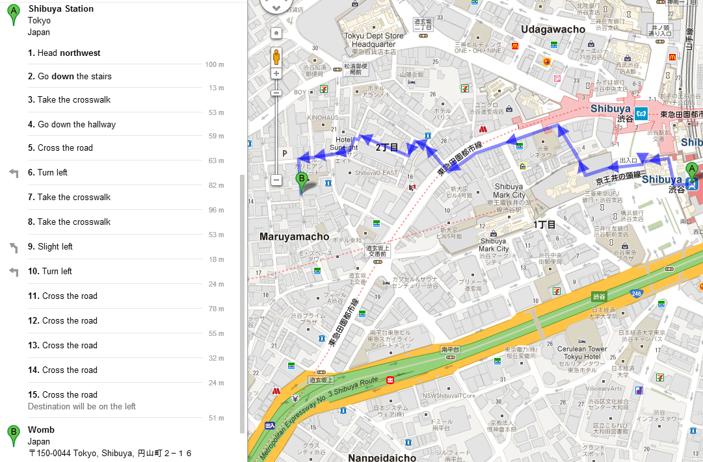

**Shinjuku to Golden Walk Factory Outlet (optional)**

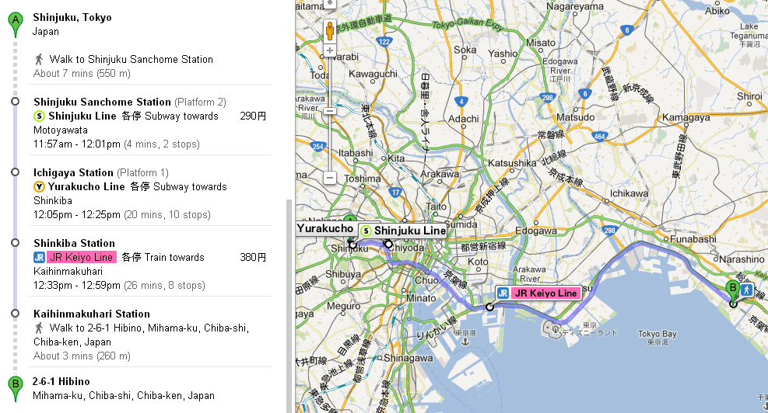

Brand fashions, household goods, sports goods, outdoor goods

Location: 1 min walk JR Kaihin-Makuhari Station

From Tokyo Station: 31 min

No. of outlets : 91

Address: 2-6-1 Hibino, Mihama-ku, Chiba-shi, Chiba Prefecture 261-0021

Phone: 043-212-8200

Operating hours: 10:00am – 20:00pm (Mon-Sun)